

REIKI TRANSMUTACIÓN CONSCIENTE

TERAPIA INTEGRAL

GUÍA DE ESTUDIO 6

INSTRUCCIONES:
- Lee todo el material correspondiente a esta guía,
- De existir inquietudes, las puedes ir apuntando en tu cuaderno de notas y llevarlas para aclararlas durante la clase.
- Cualquier inquietud urgente puedes hacerla en el chat del grupo, con gusto estaremos respondiéndola en la medida de lo posible.

2da Capa :El mesodermo

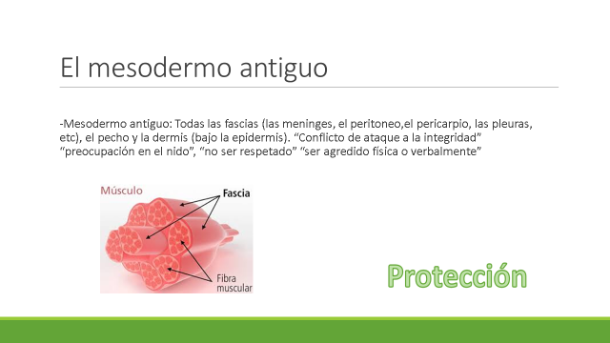
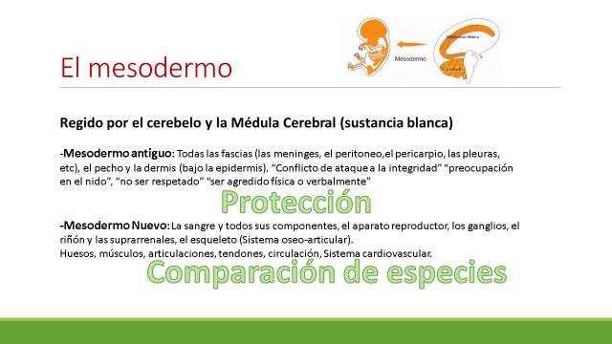

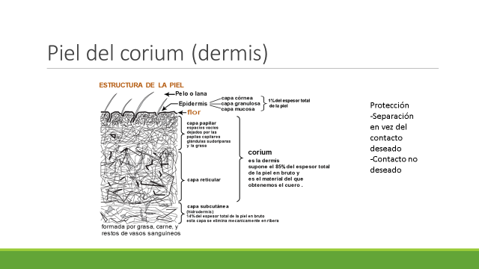
___________________________________________________________________________________________________________________________________________________________________________________________________________________________________________________________________________________________________________________________________________________________________________________________________________________________________
Peritoneo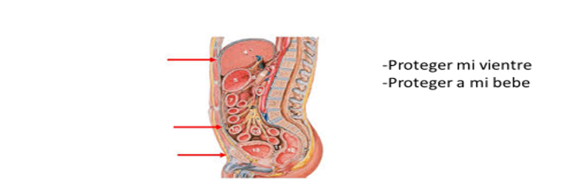
Your text here
____________________________________________________________________________________________________________________________________________________________________________________________________________________________________________________________________________________________________________________________________________________________________________________________________________________________________




